**API Documentation**

**Introduction**

Welcome to the API documentation for kazy app system. This API provides access to various functionalities of our system, allowing users to perform actions such as retrieving data, creating new records, updating existing ones, and more.

**Base URL**

<https://app.mockfly.dev/65dda8bb45810d001beca00d>

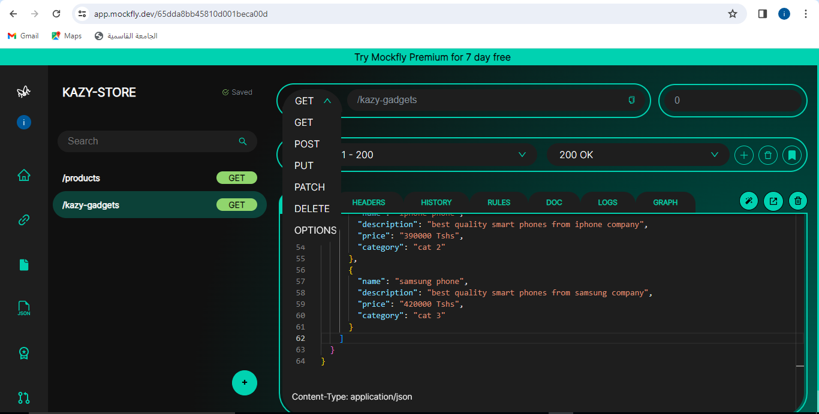

**Endpoints**

**GET /products**

Description: This endpoint retrieves data based on specified parameters.

Parameters:

* **param1**: Description of parameter 1. *(Required)*
* **param2**: Description of parameter 2. *(Optional)*

example

{

"key": "value"

}

**POST /products**

Description:

This endpoint creates a new record.

Parameters:

data: JSON object containing data for creating the record. (Required)

example

{

  "products": {

    "smart-watches": [

      {

        "name": "amazon watches",

        "description": "best quality smart watches from amazon company",

        "price": "60000 Tshs",

        "category": "cat 1"

      },

      {

        "name": "apple watches",

        "description": "best quality smart watches from apple company",

        "price": "90000 Tshs",

        "category": "cat 2"

      },

      {

        "name": "samsung watches",

        "description": "best quality smart watches from samsung company",

        "price": "120000 Tshs",

        "category": "cat 3"

      }

    ],

    "smart-tvs": [

      {

        "name": "phillips tvs",

        "description": "best quality smart tvs from phillips company",

        "price": "160000 Tshs",

        "category": "cat 1"

      },

      {

        "name": "sony tvs",

        "description": "best quality smart tvs from sony company",

        "price": "190000 Tshs",

        "category": "cat 2"

      },

      {

        "name": "hisense tvs",

        "description": "best quality smart tvs from hisense company",

        "price": "220000 Tshs",

        "category": "cat 3"

      }

    ],

    "smart-phones": [

      {

        "name": "infinix phone",

        "description": "best quality smart phones from infinix company",

        "price": "360000 Tshs",

        "category": "cat 1"

      },

      {

        "name": "iphone phone",

        "description": "best quality smart phones from iphone company",

        "price": "390000 Tshs",

        "category": "cat 2"

      },

      {

        "name": "samsung phone",

        "description": "best quality smart phones from samsung company",

        "price": "420000 Tshs",

        "category": "cat 3"

      }

    ]

  }

}

**PUT /products/{id}**

Description: This endpoint updates an existing record with the specified ID.

Parameters:

* id: The ID of the record to be updated. *(Required)*
* data: JSON object containing updated data. *(Required*

**{**

**"message": "Record updated successfully."**

**}**

**DELETE /products/{id}**

Description: This endpoint deletes the record with the specified ID.

Parameters:

* id: The ID of the record to be deleted. *(Required)*

example

**{**

**"message": "Record deleted successfully."**

**}**

**Error Handling**

In case of errors, the API will return appropriate HTTP status codes along with error messages in the response body.

* **400 Bad Request**: Indicates that the request was invalid or malformed.
* **401 Unauthorized**: Indicates that authentication is required or the provided credentials are invalid.
* **404 Not Found**: Indicates that the requested resource was not found.
* **500 Internal Server Error**: Indicates that an unexpected error occurred on the server.

**Rate Limiting**

To prevent abuse and ensure fair usage of the API, rate limiting is enforced. Exceeding the rate limit will result in a **429 Too Many Requests** response.